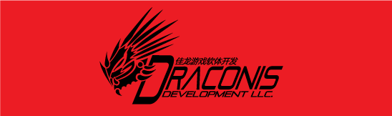

**Tyrant's Realm**

Art Guide Lines - 2D Illustration

**Asset Priority:**

Every Asset will be assigned a Priority: A, B or C

**Priority A:** 2048x2048, 9 Color Studies

* Player Characters
* Armor
* Enemy Bosses
* Player Controlled Buildings
* Key Environments

**Priority B:** 1024x1024, 6 Color Studies

* Weapons
* Crafted Items
* All enemies aside from Bosses
* All non-key environments
* Interface art

**Priority C:** 512x512, 3 Color Studies

* Material Items
* Magic Items
* Speed-Ups Items
* Treasure Chest Items

**Art Stages**:

All art will go through 3 stages of development.

**Stage 1**: Line Art

*Purpose:* This is simply the line work for the individual art asset. This will also double as our conception stage instead of a "concept art" stage.

*Process:* This stage will start with direction from ether Mark Heller, Emily Horton, or Nathanael Horton. This is just to make sure the artist understands the purpose and criteria for each asset.

The artist will then take rough pass at the design and present it for critique to ether Mark Heller, Emily Horton, or Nathanael Horton. Feedback will be rolled into the art and resubmitted. Repeat until design is approved.

Once the design is approved the artist will take this image into Photoshop and clean it. Once cleaned and approved it will be submitted to Nathanael Horton, in digital form, for archiving.

*Product:* The final result of this stage is a single .PSD file for each piece of line art (dementions vary on asset priority, 72 dpi, RGB). This file should have 3 layers: Background (fill white), Original_Line (scanned image before cleaned, layer should be hidden), and Clean_Line (final cleaned line work). This file is called the Master File.

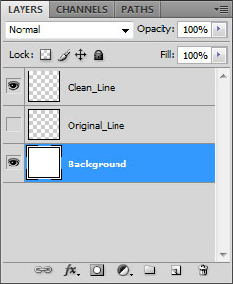

**Stage 2**: Tone

*Purpose:* In this stage tones and shadows will be added to .PSD created in Stage 1.

*Process:* Once assigned, the .PSD will be provided for assigned artist. They will add a layer folder called Tone into the file (under Clean_Line, on top of Original_Line). Any layers they create for the toning will go into this folder, the artist should not touch the three layers already in the file when they receive it. All tone will be between 0% and 95% black, no pure black.

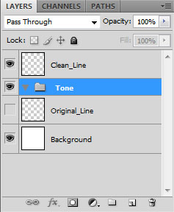

Once the artist is satisfied they can submit it for review to from ether Mark Heller, Emily Horton, or Nathanael Horton who will approve it or ask for revisions.

*Product:* Just like with Stage 1, once the toning is approved a single .PSD will be turned into Nathanael Horton for archiving. This will replace the Master File from Stage 1.

**Stage 3**: Color

*Purpose:* This stage will be where multiple versions will come into play. This stage is broken up into two delivery phases: Color Study and Final Color Variations. The Color Studies are meant to allow the artist some freedom in color pallet and provide an opening to discuss the color pallet for the Final Color Variations.

*Process:* Once assigned, the artist will receive the Master File .PSD turned in from Stage 2. They will then be given some time to do a set number of Color Studies (number of studies varies on asset priority). These can be done in any manner the artists chooses. Color Studies must be approved before moving onto the Final Color Variations.

Final Color Variations will each be done in their own layer folder (Color_01, Color_02, etc.) in the Master File .PSD. The color folder must be turned to ether 'Multiply' or 'Color' (artists choice). This will allow the color to remain separate from the tone, therefore the same tone can be used for each color variation.

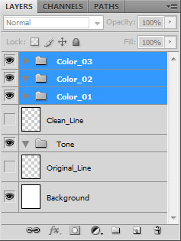

Each individual color variation must be approved before this stage is complete.

*Product:* The result of the Color Studies will be a single .JPEG file will all color studies laid out in a grid. This will be submitted to Nathanael Horton for archiving.

The result of the Final Color Variation will be an updated (and final) Master File .PSD. This will be submitted to Nathanael Horton for archiving.